**The Equalizer & The Official Publication of Mabalacat City College**



**Sprint #1**

Members:

GUNNING, IRENE L.

LAROGA, RUSSEL Z.

FRANCISCO, JULIUS D.

NICDAO, CHONNA D.

MARIN III, RUBEN F.

QUITALIG, ADRIAN F.

SANDIG, CEEJAY T.

ARCEO, SHARMAINE C.

TEAM EQUALIZER – February 16, 2017

|  |  |  |
| --- | --- | --- |
| Scrum TEAM | SPRINT NAME AND DURATION | CHANGES |
| Team Equalizer | Equalizer Sprint #1  6/Feb/17  to  16/Feb/17 | * EQUA01-Landing Page/Home Page 10 SP * Landing Page is the main page of the website it usually provides starting point with many further directions for the users and admins, containing direct links to the most important areas of interaction with a website. |
| Team Equalizer | Equalizer Sprint #2  6/Feb/17  to  16/Feb/17 | * EQUA02-Login Page(user) 5 SP   - Login page of the user, verifies the information entered by the user into the system in order to gain access. |
| Team Equalizer | Equalizer Sprint #3  6/Feb/17  to  16/Feb/17 | * EQUA03-Login Page(admin) 5 SP * Login page of the admin, verifies the information entered by the admin into the system in order to gain access. If no admin exist, the admin will be prompted to create an account |
| Team Equalizer | Equalizer Sprint #4  05/Feb/17  to  16/Feb/17 | * EQUA04-Registration Page for users and admin 5 SP   - Registration page, getting information from the users so they will be able to login thus gain more access on the portal. |
| Team Equalizer | Equalizer Sprint #5  05Feb/17  to  16/Feb/17 | * EQUA05-Database 5 SP   - Collection of data or information.   * 1. Creating Database Structure   Name: equalizer_db  Table:   * admin_tbl * announcement_tbl * articles_tbl * category_tbl * comment_tbl * issue_tbl * notification_tbl * security_tbl * user_tbl   1. Creating CRUD’s   ADMIN   * Login * Create admin * Post news * View comments * Change password * View profile   User   * Create account * Login * Comment * Update Profile * View post |

**EQUA01- Landing Page/Home Page**

Home page is the main page of the website it usually provides starting point with many further directions for the user, containing direct links to the most important areas of interaction with a website. The user may view the website.





**EQUA02- Login Page (user)**

Login page of the user, the user has access in the system so that the users will allow viewing the website.

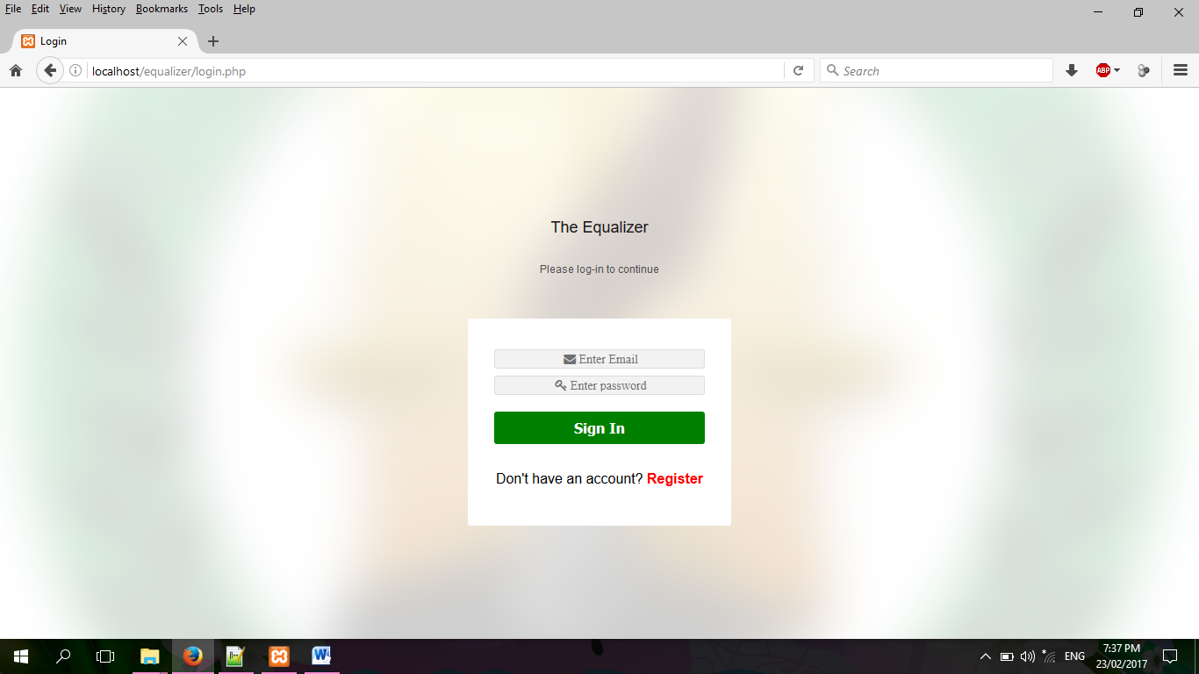

**EQUA03-Login Page (admin)**

Login page of the admin, verifies the information entered by the admin into the system in order to gain access. If no admin exist, the admin will be prompted to create an account

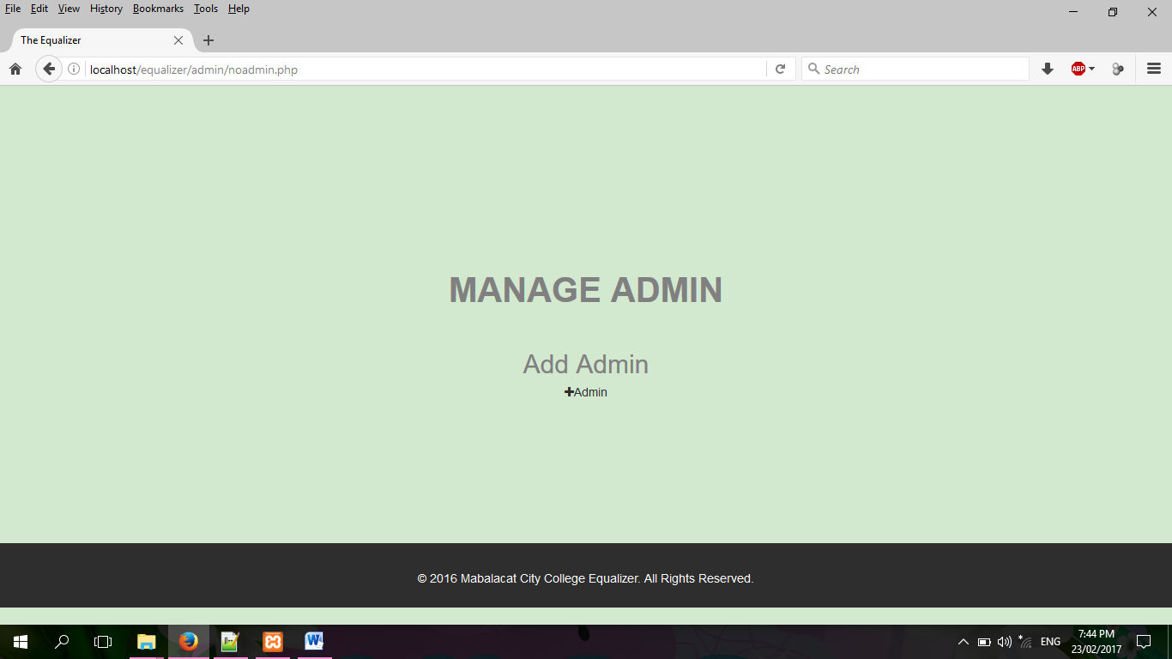

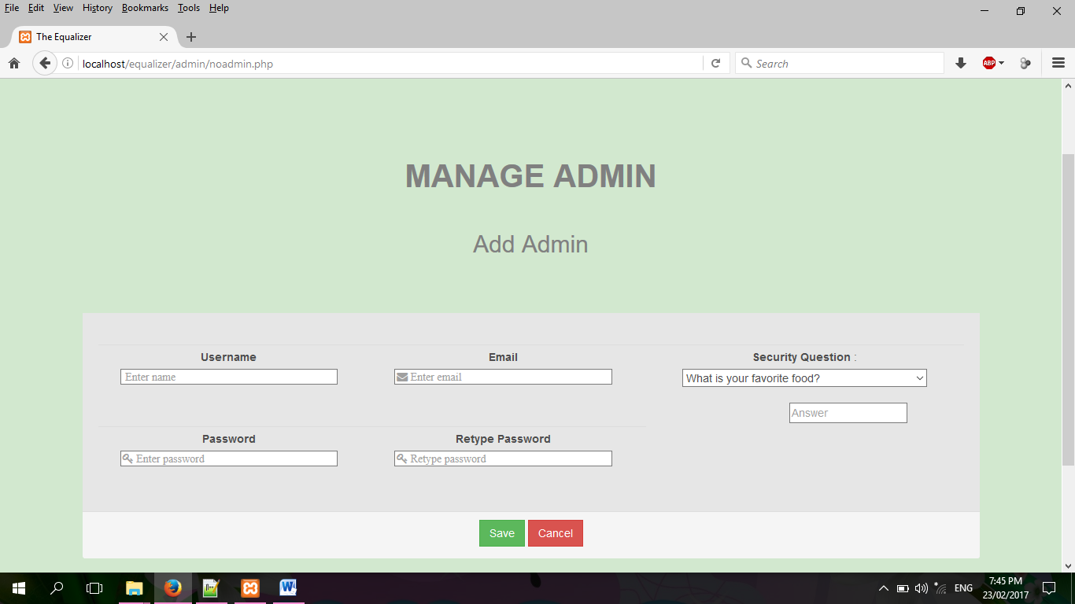



**EQUA04-Registration Page for users**

Registration page, getting information from the users so they will be able to login thus gain more access on the portal.

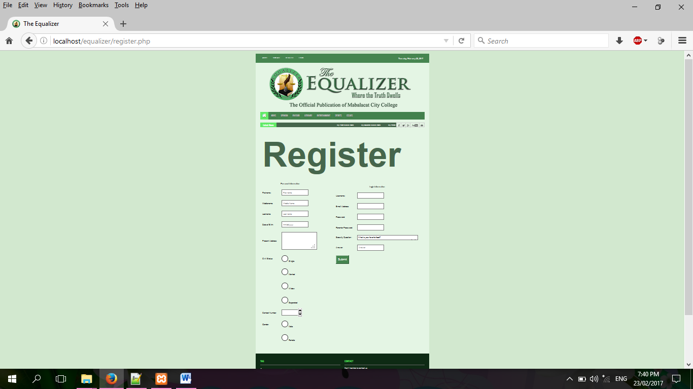

**EQUA05-Database**

Database of the system.

